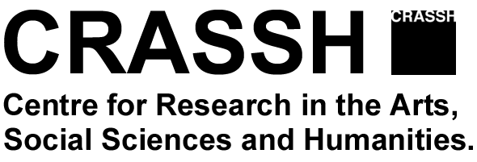

REPORT 2016-17
(Graduate/Faculty Research Groups)

Deadline: Tuesday 25 April 2017 by 12:00pm (noon) for re-applying groups.
(Final reports for groups who will not continue should be submitted by 19th June 2017)
Please upload the completed form with your application online or sent only the report to:
Esther Lamb, CRASSH, Alison Richard Building, 7 West Road, Cambridge CB3 9DT or by email to gradfac@crassh.cam.ac.uk

Details

1. Name of Graduate/Faculty Group:

Overtype here

2. Organizers Group:
(Please list, Name, Current post, Department or Institution at Cambridge and email address)

Overtype here

3. Faculty Advisors:
(Name, Current post, Institution at Cambridge)

Overtype here

4. Groups who are coming to the end of their funded period can re-apply for an extension (usually one year), apply for funding online (http://www.crassh.cam.ac.uk/programmes/apply-for-funding)

_________________________________________________________________________
Report
(Activities and how CRASSH funding has contributed to your research, up to 1000 words)

Overtype here

